Pankaj Garg

Course Proposal

Course Title | Improving mental health and well-being

Subject | Well-being and mental health | Age Group | 11+

Number of Lessons | 10 | Duration of Lessons | 60 Mins

Key Skills | Confidence building  Setting and achieving goals  Positive thinking  Mindfulness  Improving performance (exams and interviews)

Course Overview | Understanding the power of mind will enable students to understand their inner potential. It will prepare students to handle the challenges in life and more importantly not to get disappointed with failures. It will help them to have positive thinking and positive outlook in life.  It will be helpful to become confident, strong and full of self-belief. The course will prepare students to set the goals in life and persevere towards their goals. It will be helpful for personal development and improve performance in all areas of their life.  The course will include examples of few successful people and their life journey to motivate the students.  Using techniques of NLP and mindfulness, students can be benefited with tools for improving and maintaining their well-being.

Lesson Titles | Lesson 1: What is power of mind  Lesson 2: What is NLP (Neuro Linguistic Programming)  Lesson 3: What is mindfulness  Lesson 4: How to make positive changes in life  Lesson 5: How to set SMART goals (specific, measurable, achievable, relevant, time-based)  Lesson 6: How to handle challenges and failures  Lesson 7: How to build confidence and self-belief  Lesson 8: How to improve performance  Lesson 9: How to keep motivated  Lesson 10: Journey of Successful people

Picture | 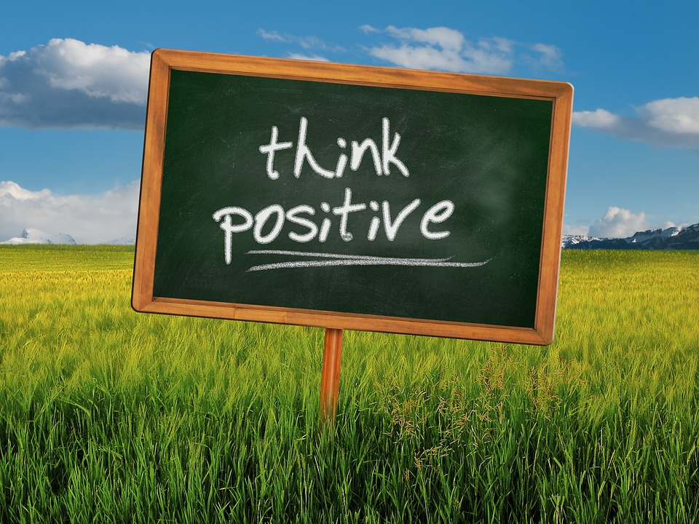  https://www.google.co.uk/url?sa=i&url=https%3A%2F%2Fpixabay.com%2Fillustrations%2Ffield-barley-sky-clouds-think-328962%2F&psig=AOvVaw14hPOQ0ZWxD8RmE9IZVwWt&ust=1597867568643000&source=images&cd=vfe&ved=0CAIQjRxqFwoTCOj9yOnGpesCFQAAAAAdAAAAABAQ

