Pankaj Garg

Course Proposal

Course Title | Building confidence

Subject | Well-being and mental health | Age Group | 11+

Number of Lessons | 8 | Duration of Lessons | 60 Mins

Key Skills | Confidence building  Setting and achieving goals  Positive thinking  Self esteem building

Course Overview | Understanding the power of mind will enable students to understand their inner potential and provide them the tool to improve confidence. Methods will be provided to build their ability to have positive thinking and positive outlook in life.  The course will be helpful for student to become more confident in all areas of their life. It will be helpful for personal development and building self esteem.  The course will talk about the various successful people and what is different in them that makes them successful. The course will include examples of few successful people and their life journey to motivate the students and build their confidence.  Using techniques of NLP and mindfulness, students can be benefited with tools for improving and maintaining their confidence.

Lesson Titles | Lesson 1: Using the power of mind to improve confidence  Lesson 2: Build the ability to think positive  Lesson 3: How to make positive changes in life  Lesson 4: How to build confidence and self-belief  Lesson 5: How to handle challenges and failures  Lesson 6: What is different in successful people  Lesson 7: Biography of successful people in their field  Lesson 8: Role of hypnotherapy and self-hypnosis to improve confidence

Picture | 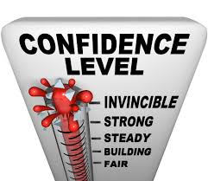  https://www.google.co.uk/url?sa=i&url=https%3A%2F%2Fwww.flickr.com%2Fphotos%2F59632563%40N04%2F6664212003&psig=AOvVaw1ytRLb9ewXU5wroAjMkoG-&ust=1598616724564000&source=images&cd=vfe&ved=0CAIQjRxqFwoTCKj0nNitu-sCFQAAAAAdAAAAABAH

